Mini Project:
1.Problem Statement: Build a complete pipeline that reads a CSV file from Blob Storage and processes it using Azure Data Factory.
Requirements:
- Source: CSV file in Blob
- Use: Linked Service + Dataset + Pipeline
- Process: Copy Data + Metadata check
- Destination: New file/location
2.Architecture Diagram: 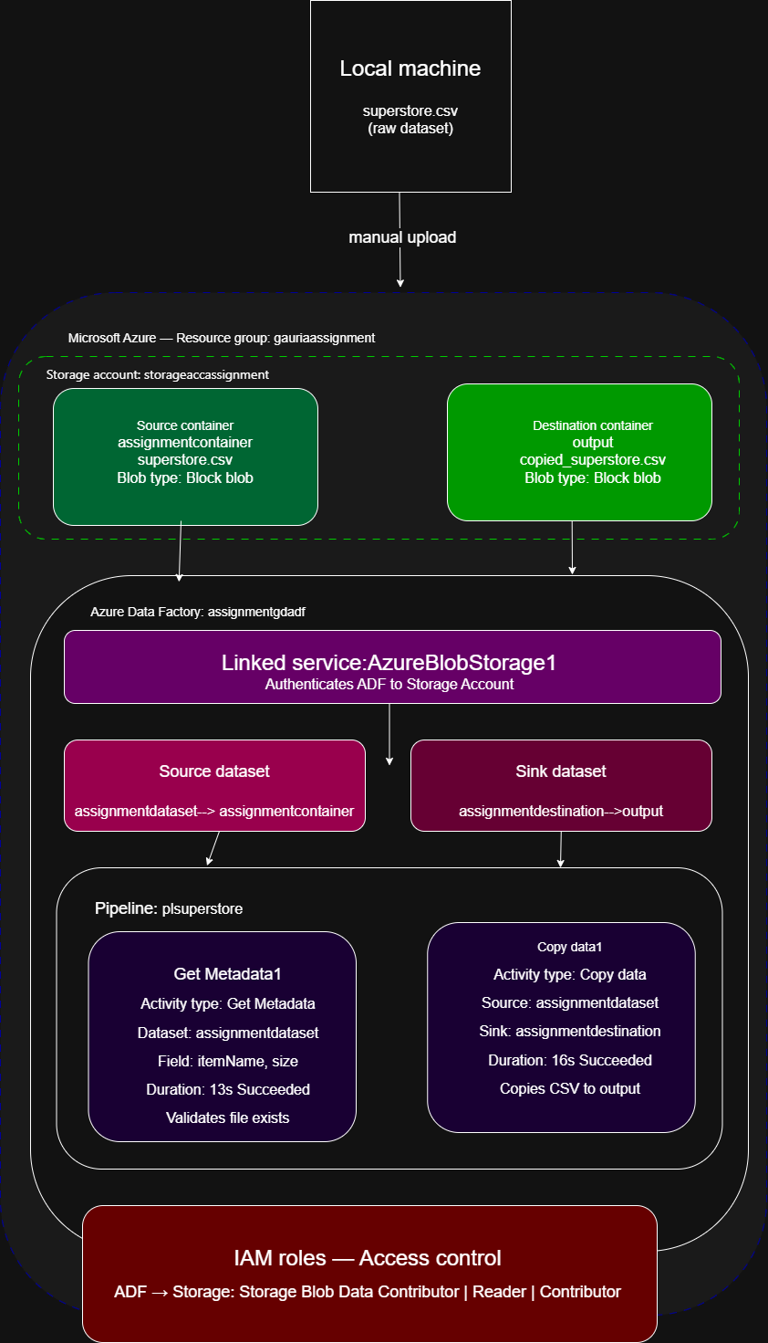
3. Architecture Screenshot:
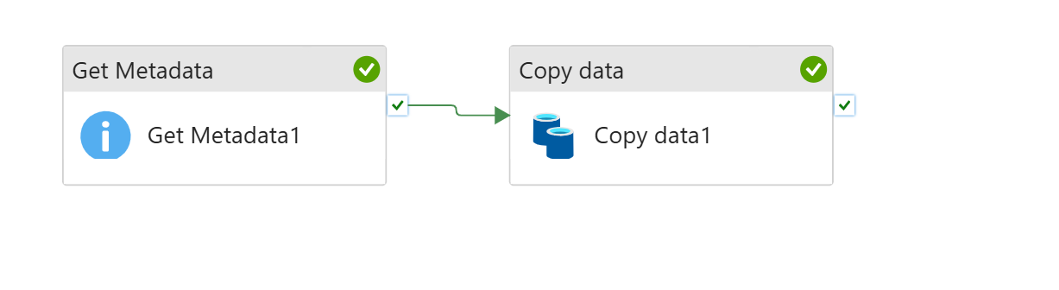4. Execution Process:

Step 1: Resource Group Creation
The first step was to create a Resource Group named “gauriassignment” in the Azure Portal. The Resource Group acts as a logical container that holds all Azure resources related to this project.
Purpose:
- Organize project resources.
- Simplify resource management.
Resource Group Name:
- gauriassignment

Step 2: Storage Account Setup
A Storage Account was created within the Resource Group to store the project data files.
Purpose:
- Store source and destination files.
- Provide Blob Storage capabilities.
- Serve as the data source and destination for Azure Data Factory.

Step 3: Blob Container Creation
Two Blob Containers were created inside the Storage Account:
Source Container
Container Name:
- assignmentcontainer
Purpose:
- Store the source dataset.
Destination Container(created automatically in ADF)
Container Name:
- output
Purpose:
- Store the processed output file generated by the pipeline.

Step 4: Uploading the Dataset
The Superstore dataset (CSV file) was uploaded into the source container.
Source File:
- Sample - Superstore.csv
Location:
- assignmentcontainer
Purpose:
- Act as the input dataset for the data pipeline.

Step 5: Azure Data Factory Creation
An Azure Data Factory instance named “assignmentgdadf” was created.
Purpose:
- Build and manage data pipelines.
- Connect data sources and destinations.
- Perform metadata validation and data movement.

Step 6: Exploring Azure Data Factory
The Azure Data Factory Studio interface was explored.
Author Section
Used to create:
- Pipelines
- Datasets
- Data Flows
- Linked Services
Monitor Section
Used to:
- Track pipeline executions
- Monitor activity runs
- View execution status and logs
Manage Section
Used to:
- Create Linked Services
- Configure Integration Runtime
- Manage access and connections

Step 7: Linked Service Configuration
A Linked Service was created to establish connectivity between Azure Data Factory and Azure Blob Storage.
Linked Service Name:
- AzureBlobStorage1
Purpose:
- Store connection information.
- Allow Azure Data Factory to access Blob Storage resources.
Result:
- Connection tested successfully.

Step 8: Dataset Creation
Two datasets were created.
Source Dataset
Dataset Name:
- assignmentdataset
Configuration:
- Azure Blob Storage
- Delimited Text (CSV)
Source File:
- Sample - Superstore.csv
Purpose:
- Represent the source CSV file.
Destination Dataset
Dataset Name:
- assignmentdestination
Configuration:
- Azure Blob Storage
- Delimited Text (CSV)
Destination File:
- salesoutput.csv
Container:
- output
Purpose:
- Represent the output file location.

Step 9: Metadata Validation using Get Metadata Activity
A pipeline was created and a Get Metadata activity was added.
Activity:
- Get Metadata
Dataset:
- assignmentdataset
Fields Retrieved:
- Exists
- Size
Purpose:
- Verify that the source file exists.
- Retrieve file size information before processing.
Result:
- Metadata validation completed successfully.
- File existence confirmed.
- File size retrieved successfully.

Step 10: Data Copy using Copy Data Activity
A Copy Data activity was added to the pipeline.
Source:
- assignmentdataset
Destination:
- assignmentdestination
Purpose:
- Copy data from the source container to the destination container.

Pipeline Flow:
Get Metadata
↓
Copy Data

Result:
- Data copied successfully.

Step 11: Pipeline Execution
The pipeline was executed using the Debug option in Azure Data Factory.
Execution Steps:
- Get Metadata activity executed.
- Metadata validation completed.
- Copy Data activity executed.
- Data transferred successfully.
Pipeline Status:
- Succeeded
Result:
- Pipeline executed without errors.

Step 12: Monitoring Pipeline Execution
The execution was monitored using the Monitor section of Azure Data Factory.
Monitored Information:
- Pipeline status
- Activity status
- Execution duration
- Error logs
Result:
- Both activities completed successfully.
- Pipeline status displayed as Succeeded.

Step 13: Verifying Output Data
After successful execution, the destination container was checked.
Destination Container:
- output
Output File:
- salesoutput.csv
Verification:
- Output file was generated successfully.
- Data was copied correctly from source to destination.
- assignmenttgdadf (Azure Data Factory Managed Identity)
Purpose:
- Allow Azure Data Factory to read and write data in Blob Storage.
Result:
- Secure communication established between Azure Data Factory and Azure Storage.
5)Results:
- Resource Group created successfully.
- Storage Account configured successfully.
- Blob Containers created successfully.
- Superstore dataset uploaded successfully.
- Linked Service established successfully.
- Source and Destination datasets created successfully.
- Metadata validation completed successfully.
- Data copied successfully.
- Pipeline execution completed with Succeeded status.
- Output file generated successfully.
- IAM roles configured successfully.

6)Screenshots
Pipeline executed successfully:-
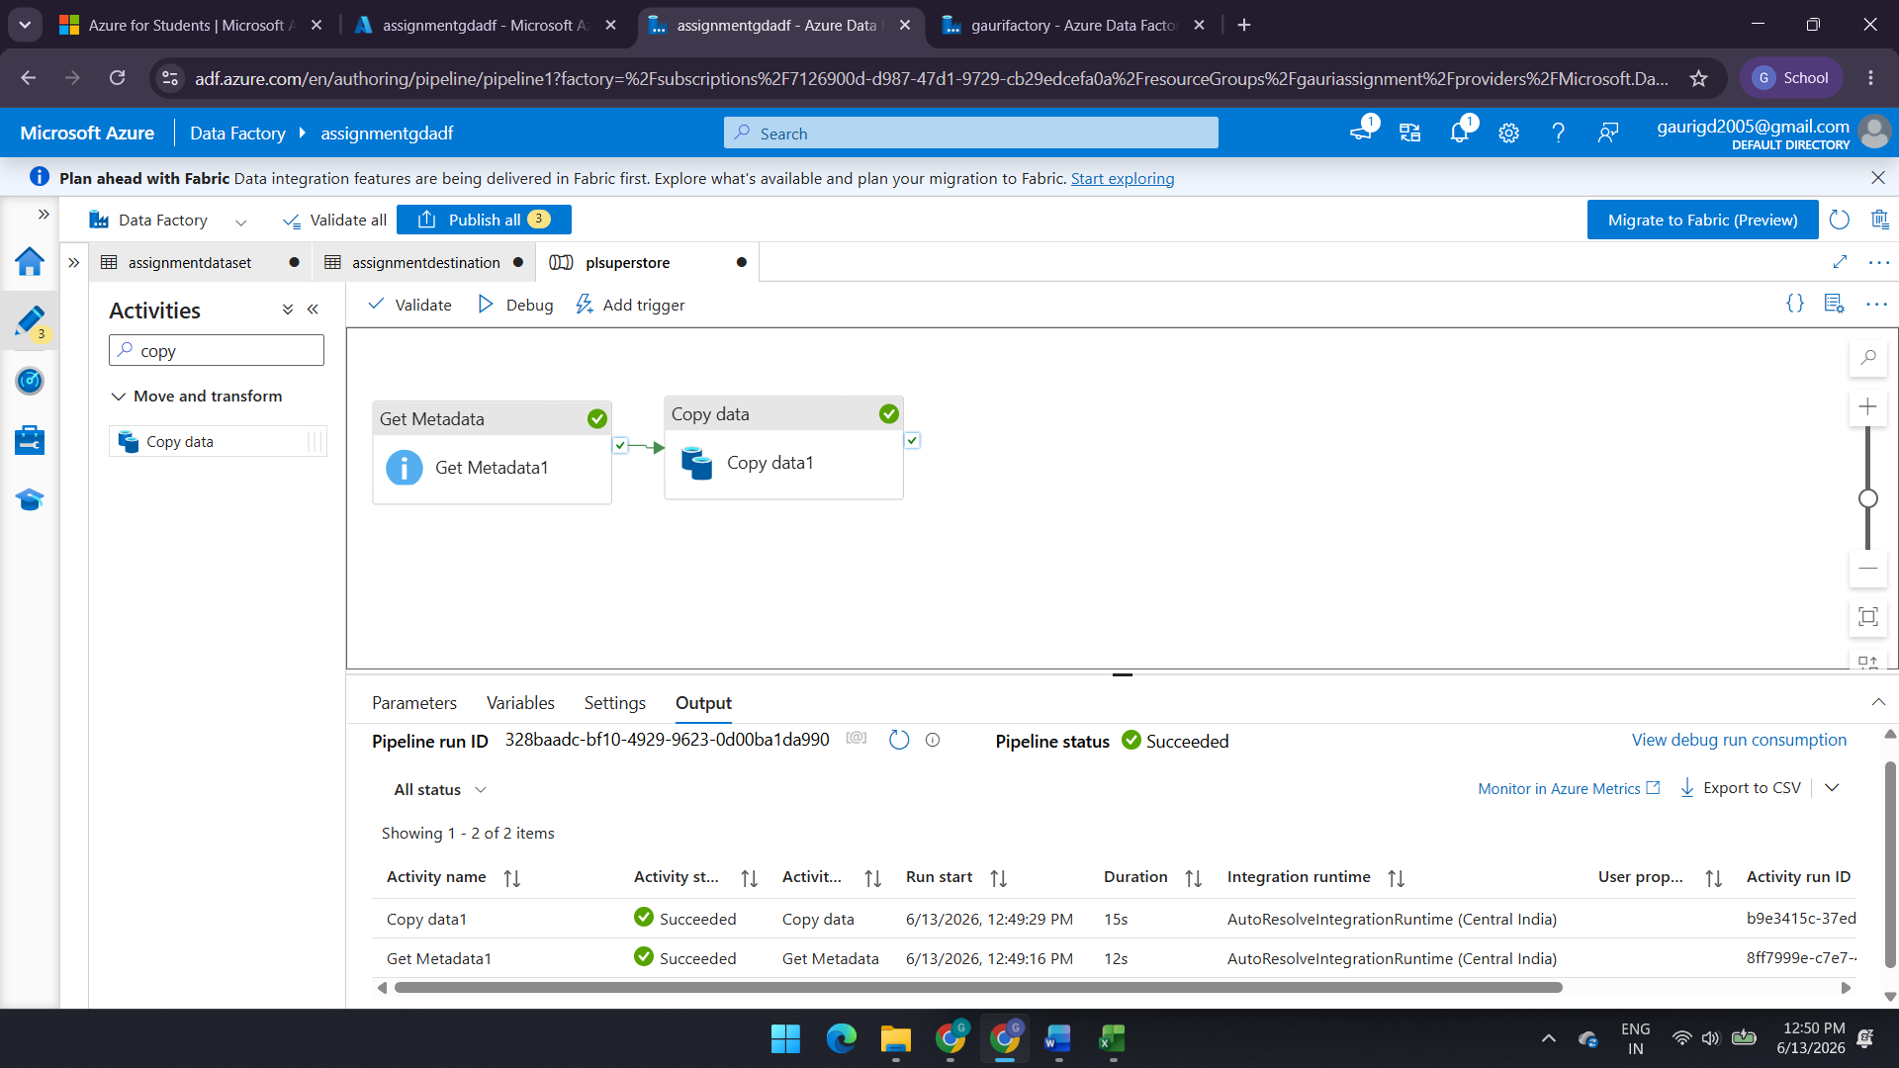

Data copied to destination :-
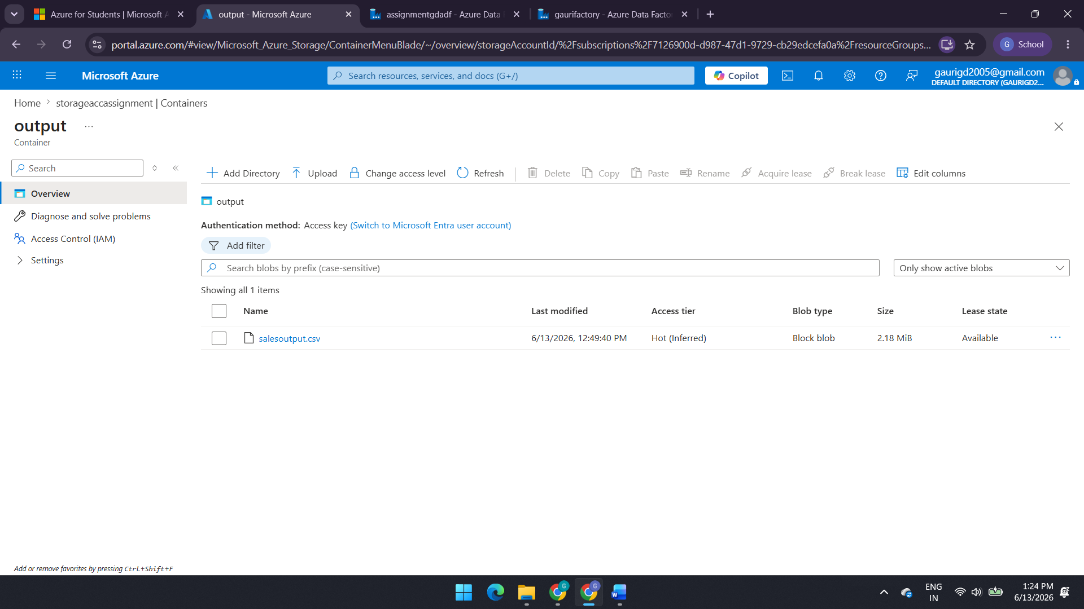

Metadata validated :-
